Circle study guide due Thursday November 14th

1) A circle has a diameter of 15 inches. What is the circumference? Use 3.14 to approximate . | 2) A circle has a radius of 2.5 centimeters. What is the area? Use 3.14 to approximate .
3) skip | 4) Circle A has a circumference of 14units. Circle B has an area of 16square units. Which circle has the bigger radius?
5) A large pizza has a circumference of approximately 43.96 inches². What is the diameter of the pizza? Use 3.14 to approximate .  A. 7 inches  B. 8 inches  C. 10 inches  D. 14 inches | 6) Marquis is hungry for pizza! He has a choice between Pizza A: Half of a 16 inch pizza or Pizza B: A whole 10 inch pizza to himself. Which pizza would ensure him the largest amount?

7) Observe the below table.  d Diameter (Centimeters) a Area (Square Centimeters)  3 7.065  6 28.26  7 38.465  12 113.04  Is there a proportional relationship between diameter and area of circles? | 8) Use the graph to answer the below questions.  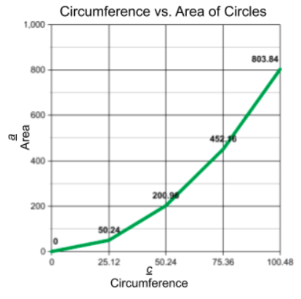  Does there appear to be a proportional relationship between circumference and radius?
9) Complete the table.  d Diameter (Centimeters) c Circumference (Centimeters)  8 50.24  9  78.5  615.44  Determine an equation that can be used to predict the circumference of any circle given the diameter. | 10) Circle P has a radius of 8 inches. The shortest distance between Q and R is 6.28 inches. What is the approximate area of the remaining part of the circle? Note the part that has the dotted line on the outside.  A. Approximately 25.12 square inches  B. Approximately 50.24 square inches  C. Approximately 175.84 square inches  D. Approximately 200.96 square inches

